A Project On
Regulatory Quality in Japan and Russia between 2016-2021
By
Mayukh Paul
B.S.C Economics-3rd Year-5Th Year
Enrolment no. 2211212001006

Date Of Submission: 20th November 2024


ECONOMICS DEPARTMENT
SISTER NIVEDITA UNIVERSITY, KOLKATA

INDEX

ABSTRACT
This presentation explores the regulatory quality of Japan and Russia, focusing on how governance impacts economic performance, business environments, and societal outcomes. Regulatory quality is defined as the ability of governments to design and enforce rules that promote business activity, protect consumer rights, and ensure economic stability.

The comparative analysis highlights Japan's transparent and business-friendly regulatory framework, which supports economic resilience and investor confidence. In contrast, Russia faces challenges such as inconsistent enforcement, corruption, and bureaucratic hurdles, which hinder business growth and investment. Key indicators such as ease of doing business, compliance costs, and governance rankings underline the stark differences between the two nations.

Case studies on Japan's Abenomics reforms and disaster management showcase its adaptability and stability, while Russia's financial crisis response and pandemic measures reveal ongoing struggles with regulatory unpredictability. Recommendations include improving transparency, reducing bureaucracy, and fostering international cooperation to enhance regulatory environments in both countries. The findings provide actionable insights into how regulatory quality shapes economic and social outcomes globally.

INTRODUCTION
Regulatory quality refers to the government's ability to create and implement effective rules that foster economic growth, protect consumer rights, and ensure a fair business environment. This presentation examines the regulatory frameworks of Japan and Russia, comparing their strengths, weaknesses, and overall impact on economic performance. By analysing key indicators and case studies, it aims to highlight the importance of sound regulatory policies in shaping stable and sustainable economies.

OBJECTIVE
The objective of exploring the regulatory quality of Japan and Russia is to understand how each country's rules and regulations affect businesses, investment, and overall economic stability. By comparing these two countries, we aim to identify the strengths and weaknesses in their regulatory systems and how these factors impact growth, fairness, and social well-being.

LITERATURE REVIEW
The literature on regulatory quality shows that effective regulations are crucial for economic stability and growth. In Japan, regulations are generally seen as transparent and supportive of business, with strong protections for property rights and fair competition. This creates a stable environment for investment and development. In contrast, Russia faces challenges with inconsistent rule enforcement, corruption, and a less predictable regulatory environment, which can hinder business growth and investor confidence. These differences highlight how regulatory quality can shape the economic and social outcomes in each country.

COMPARATIVE ANALYSIS BETWEEN JAPAN AND RUSSIA
Overview of Japan’s regulatory bodies
- Ministry of Economy, Trade, and Industry (METI)
Role: The Ministry of Economy, Trade and Industry role in shaping Japan's industrial and economic policies. Its mission focuses on fostering economic growth, innovation, and international trade, while ensuring that business regulations remain conducive to competitive markets and sustainable development.
Key Functions:
- Oversees economic policy, trade, industrial innovation, and energy management to promote economic growth.
- Regulates financial institutions to ensure stability, transparency, and investor protection within Japan's financial markets​
- Enforces anti-monopoly laws to maintain fair competition and prevent anti-competitive practices
- Sets monetary policy and manages inflation to ensure financial stability across Japan’s economy

Key regulations
- Commercial Code of Japan: The Commercial Code of Japan is a set of laws that govern business activities in Japan. It covers rules for how companies should be formed and managed, how contracts are made and enforced, and how businesses can handle disputes. It’s designed to keep business practices fair, protect shareholders, and ensure transparency in the way companies operate.
The code also governs commercial contracts and other business transactions, such as sales agreements and commercial leases. Reforms have been periodically introduced to adapt the law to global business practices, such as the Corporate Governance Code introduced in 2015.

2. Financial Instruments and Exchange Act (FIEA): The FIEA regulates securities markets, including the issuance and trading of stocks, bonds, and derivatives. It aims to ensure market transparency, protect investors, and prevent market manipulation. This act requires financial institutions to maintain proper disclosure practices, mandates the registration of securities, and sets standards for trading activities. It also covers areas such as insider trading, anti-money laundering measures, and corporate governance.
Overview of Russia's regulatory bodies
- Ministry of Economic Development (MED)
Role: The Ministry of Economic Development is responsible for shaping and implementing Russia’s economic policy, including issues related to economic growth, investments, and regional development. It also works on improving the business climate by proposing reforms to reduce bureaucratic barriers and enhance economic competitiveness.

Key Functions:

- Drafting and executing economic policies and strategies.

- Overseeing investment and development projects.

- Managing federal programs aimed at improving business regulation.

- Collaborating with other ministries to improve regulatory frameworks.
- Central Bank of Russia (CBR)
Role: The Central Bank of Russia is responsible for regulating the financial system, ensuring monetary stability, and maintaining a stable banking system. It plays a central role in economic regulation, managing inflation, and setting interest rates.
Key Functions:
- Regulating and supervising financial institutions, including banks and insurance companies.
- Issuing the national currency, the ruble, and managing foreign exchange reserves.
- Overseeing the implementation of monetary policy, including controlling inflation and stabilizing the financial system.
- Promoting financial market development and protecting consumers from fraud.

COMPARISONS BETWEEN JAPAN AND RUSSIA
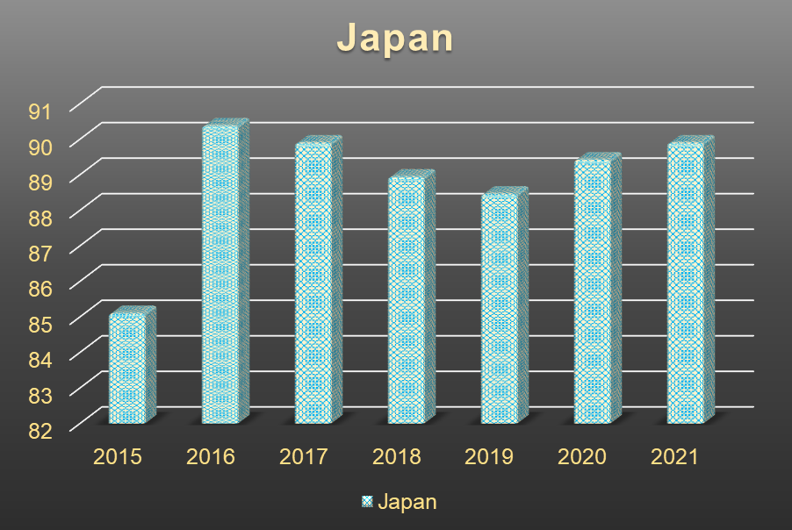

Consumption Tax Increase (2014): April, 2014 Japan raised its tax from 5% to 8% to address in public high debt.
Peak in 2016: The highest score, 90.38 in 2016, may reflect efforts to improve transparency and efficiency, as Japan focused on reforming corporate governance and fostering innovation.
Slight Decline: Minor declines in 2017, 2018, and 2019 could suggest external factors, such as trade tensions and domestic adjustments, impacting regulatory performance slightly but not substantially.
Resilience During COVID-19: The relatively stable score in 2020 (89.42) demonstrates Japan’s adaptability in maintaining regulatory effectiveness amid the economic disruptions caused by the pandemic.
Consistent Recovery: The rebound to 89.9 in 2021 suggests sustained efforts to maintain regulatory quality, showing Japan's commitment to stability and support for the private sector.
Overall, Strength: Japan’s regulatory scores reflect a strong, consistent framework that fosters a reliable environment for businesses, crucial for economic resilience and recovery.
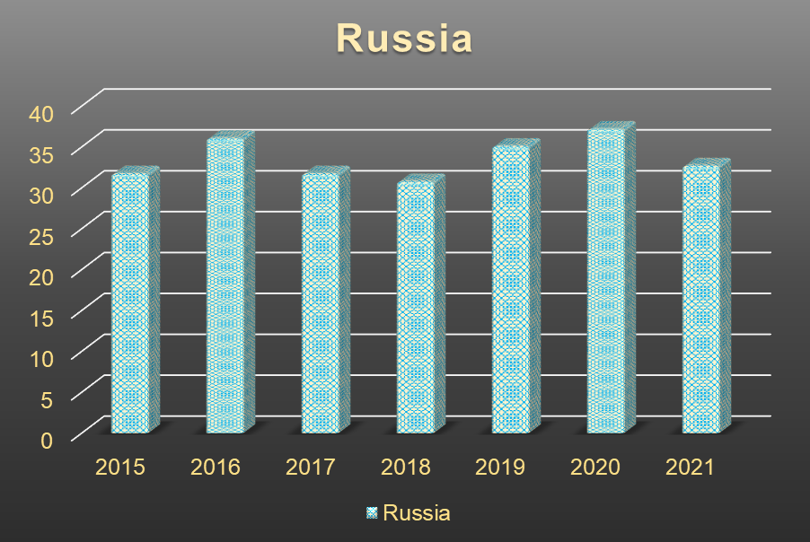

Moderate Scores: Russia’s scores ranged from 30.77 to 37.2, indicating moderate regulatory quality with significant room for improvement.
Fluctuations: Scores varied across the years, suggesting inconsistent regulatory performance influenced by both internal policies and external pressures.
Improvement Attempts: The increase in 2016 and again in 2020 could reflect governmental efforts to improve regulatory effectiveness, likely influenced by reforms in response to economic challenges.
Sanctions and Global Tensions: The lower scores in 2018 and 2021 may be associated with heightened international sanctions and geopolitical tensions, which strained regulatory stability. COVID-19 Impact: The slight improvement in 2020 suggests adaptability during the COVID-19 pandemic, with Russia implementing measures to stabilize its regulatory environment despite economic disruption.
Overall Challenges: Consistent fluctuations indicate ongoing challenges in regulatory quality, often due to political and economic factors that hinder stable regulatory development.
CASE STUDY
1. Abenomics and Economic Reforms (2015-2020)
Impact on Rank: 85.1 (2015) → 90.38 (2016)
Abenomics, introduced by Prime Minister Shinzō Abe, aimed to revive Japan’s economy through monetary easing, fiscal stimulus, and structural reforms.
The regulatory reforms encouraged private-sector growth, promoted corporate governance improvements, and fostered greater market transparency.
These reforms were designed to make Japan a more attractive place for both domestic and international investors.
Effect on Rank: Abenomics, along with other reforms, likely contributed to an improvement in Japan’s regulatory quality, as markets became more stable and predictable. The ranking improvement from 2015 to 2016 (85.1 to 90.38) reflects these positive changes.
2. Regulatory Response to Natural Disasters (2016-2020)
Impact on Rank: 89.42 (2020) → 89.9 (2021)
Japan has a long history of dealing with natural disasters. The 2016 Kumamoto Earthquake and other events prompted updates to disaster management laws and construction safety regulations.
These adjustments aimed to protect infrastructure, businesses, and citizens, reinforcing Japan’s regulatory resilience.
Effect on Rank: The effective management of natural disasters contributed to market stability and resilience, which reinforced Japan’s high regulatory quality. This likely played a role in maintaining a high rank (89.9 in 2021).
1. Russian Currency Crisis and Financial Reforms (2014-2017)
Impact on Rank: 36.06 (2016) → 31.73 (2017)
In 2014, the ruble crisis occurred due to the falling price of oil and ongoing international sanctions. The Russian government responded with a combination of financial stabilization measures, including interest rate hikes and currency interventions by the Central Bank of Russia.
Over the following years, the government introduced financial reforms to stabilize the banking sector and manage inflation. However, these measures also led to heightened regulatory oversight of the financial system.
Despite these efforts, investor confidence in Russia remained relatively low, and there were concerns over the predictability and transparency of regulations in the country, contributing to its lower ranking.
Effect on Rank: The continued financial instability and concerns over regulatory uncertainty likely contributed to a drop in Russia’s ranking in 2017, where it remained at 31.73.

2. COVID-19 Pandemic Response (2020-2021)
Impact on Rank: 35.1 (2019) → 32.69 (2021)
Like many other countries, Russia’s response to the COVID-19 pandemic required quick regulatory adaptations. The government-imposed lockdowns and enacted measures like economic stimulus packages, tax deferrals, and support for small businesses to mitigate the economic damage from the pandemic.
Additionally, Russia's government was heavily involved in managing the healthcare crisis, which required new regulations related to public health and safety, travel restrictions, and quarantine protocols.
While the pandemic response showed some flexibility in regulatory adaptation, the economic and political landscape still posed challenges for investor confidence and market stability.
Effect on Rank: Despite the regulatory responses to the pandemic, Russia’s business climate remained affected by factors such as political instability, sanctions, and the economic slowdown, leading to a small decrease in the regulatory quality rank from 35.1 in 2019 to 32.69 in 2021.

CONCLUSION

To improve regulatory quality, Japan and Russia should implement key reforms. Japan should simplify labour laws, relax immigration rules, increase transparency in government procurement, streamline startup licensing, and digitize processes. Russia should simplify business registration, reduce bureaucracy and corruption, enhance transparency in decision-making, protect intellectual property, and promote competition. Both countries should adopt electronic governance, encourage public participation, foster international cooperation, support small businesses, and train regulatory officials. By setting clear goals, engaging stakeholders, monitoring progress, and sharing knowledge internationally, Japan and Russia can enhance their business environments, promote economic growth, and improve regulatory quality.

Reference
FocusEconomics 2024
Statista 2024
Cabinet Office - Disaster Management
The Journal of Japanese Studies or Asian Economic Policy Review
World Bank's Doing Business Report, OECD's Regulatory Policy Outlook, IMF's Country Reports, National statistics offices (Japan, Russia)

APPENDIX

Regulatory Quality of Japan from 2015-2021
Year | Rank
2015 | 85.1
2016 | 90.38
2017 | 89.9
2018 | 88.94
2019 | 88.46
2020 | 89.42
2021 | 89.9

Regulatory Quality of Russia from 2015-2021
Yearly Rank
2015 31.73
2016 36.06
2017 31.73
2018 30.77
2019 35.1
2020 37.2
2021 32.69

